**Date: 18-09-2021**

**Experiment 5**

**Aim:** To work with MATLAB user defined functions.

**Apparatus:** MATLAB Software

**Objective:** To learn how to develop and debug sub-tasks independently before building the final program.

**Problems:**

**Q-1.** It is often useful to be able to simulate the throw of a fair die. Write a MATLAB function dice that simulates the throw of a fair die by returning some random integer between 1 and 6 every time that it is called. (*Hint:* Call random0 to generate a random number. Divide the possible values out of random0 into six equal intervals and return the number of the interval that a given random value falls into.)

**Code:**

clear all;

close all;

Num = dice();

fprintf("Random Number Generated: %d ",Num);

**Dice Function:**

function number = dice()

number = randi(6);

end

**Output:**

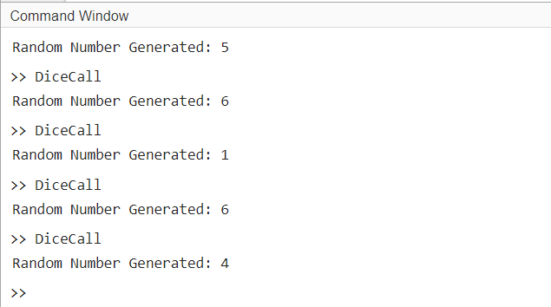

**Q-2.** A function is said to be recursiveif the function calls itself. MATLAB functions are designed to allowrecursive operation. To test this feature, write a MATLAB function toevaluate the factorial function, which is defined as follows:

**

where *N* is a positive integer. The function should check to make sure that there is a single argument *N*, and that *N* is a nonnegative integer. If it is not, generate an error using the error function. If the input argument is a nonnegative integer, the function should evaluate *N*! using Equation.

**Code:**

clc;

clear all;

close all;

x = input("Enter your Number: ");

y = factorial(x);

if y == -1

fprintf("Invalid Entry")

else

fprintf("Factorial of %d is %d ",x,y);

end

**Factorial Function:**

function fact = factorial(n)

if nargin == 1

if n == 0

fact = 1;

elseif n < 0

fact = -1 ;

else

fact = n * factorial(n-1);

end

else

error('Number of Argument is not equal to 1');

end

end

**Output:**

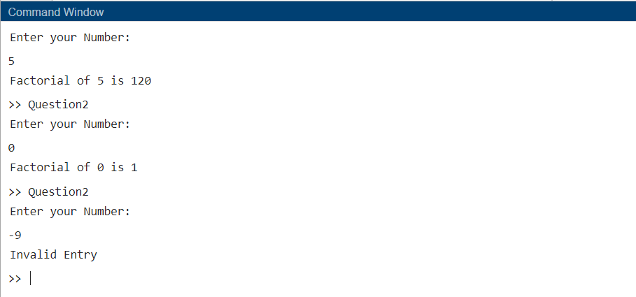

**Q-3.** Antiship missiles (ASMs) are sometimes used to attack naval ships, and the ships being attacked use surface-to-air missiles (SAMs) to try to kill the attacking missiles before they hit the ship. Answer the following questions about this situation using the function developed in previous exercise.

(*a*) If the ship uses three SAMs to attack an incoming ASM and the probability of success of each attack is 0.3, what is the probability that the ship will destroy the ASM before it is hit?

(*b*) If the ship uses three SAMs to attack an incoming ASM and the probability of success of each attack is 0.5, what is the probability that the ship will destroy the ASM before it is hit?

(*c*) If the ship uses three SAMs to attack an incoming ASM and the probability of success of each attack is 0.7, what is the probability that the ship will destroy the ASM before it is hit?

(*d*) If the ship uses three SAMs to attack an incoming ASM and the probability of success of each attack is 0.9, what is the probability that the ship will destroy the ASM before it is hit?

**Code:**

clc;

clear all;

close all;

success = 0.3:0.2:0.9;

fail = 1- success;

n=3;

r = 0;

probab = nCr(n,r).* power(success,r) .* power(fail,n-r);

hit = 1 - probab;

fprintf("Sr. \tProbablity(Destroy)")

fprintf("\n1. \t%f",hit(1));

fprintf("\n2. \t%f",hit(2));

fprintf("\n3. \t%f",hit(3));

fprintf("\n4. \t%f",hit(4));

function C = nCr(n,r)

C = factorial(n) /(factorial(n-r) * factorial(r));

end

function fact = factorial(n)

if n == 0

fact = 1;

else

fact = n * factorial(n-1);

end

end

**Output:**

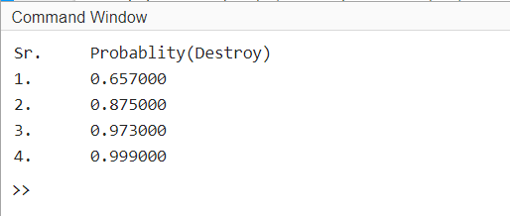

**Q-4.** Suppose a designer wanted to ensure that there is a 90% probability that the ship will survive an ASM attack without being hit. How many SAMs should the ship fire to destroy the incoming ASM if the individual probability of success of for a SAM is (*a*) 30%? (*b*) 50%? (*c*) 70%?

**Code:**

function Question4

ans1 = 0.9;

P0 =1-ans1;

p=0.3:0.2:0.7;

q=1-p;

n = round(log(P0)./log(q))

end

**Output:**

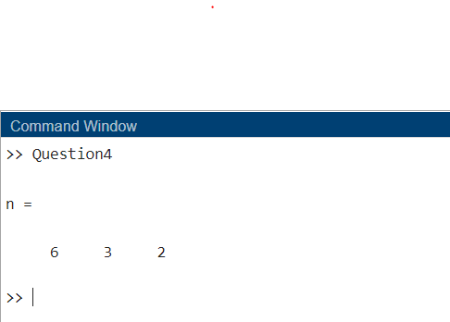

**Q-5.** Write three MATLAB functions to calculate the hyperbolic sine, cosine, and tangent functions:



Use your functions to plot the shapes of the hyperbolic sine, cosine, and

tangent functions.

**Code:**

clc;

clear all;

close all;

x = -pi/2:pi/10:pi/2;

while true

fprintf("\n1. Sinh(x)");

fprintf("\n2. Cosh(x)");

fprintf("\n3. tanh(x)");

fprintf("\n4. Exit");

c = input("\nEnter Your Choice");

switch c

case 1

Sinh(x)

case 2

Cosh(x)

case 3

Tanh(x)

case 4

break;

otherwise

fprintf("\nInvalid Choice");

end

end

function Sinh(x)

ans1 = (exp(x) - exp(-x))/2;

figure

plot(x,ans1,"LineStyle",'-.',"Color",'red')

xlabel('Angle')

ylabel('Sinh')

title('Sinh(x)')

end

function Cosh(x)

ans1 = (exp(x) + exp(-x))/2;

figure

plot(x,ans1,"LineStyle",'--',"Color",'yellow')

xlabel('Angle')

ylabel('Cosh')

title('Cosh(x)')

end

function Tanh(x)

ans1 = (exp(x) - exp(-x))./(exp(x) + exp(-x));

figure

plot(x,ans1,"LineStyle",'-.',"Color",'b')

xlabel('Angle')

ylabel('tanh')

title('tanh(x)')

end

**Output:**

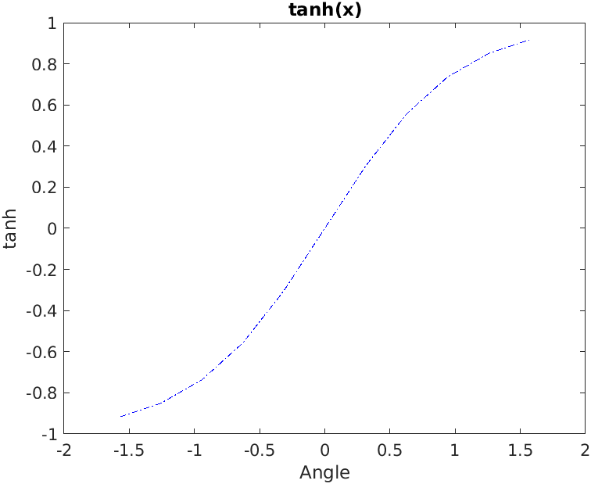

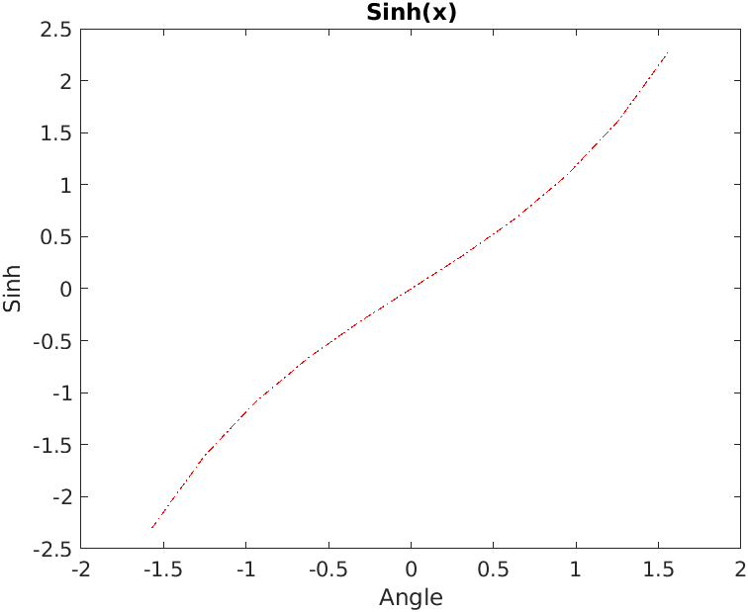

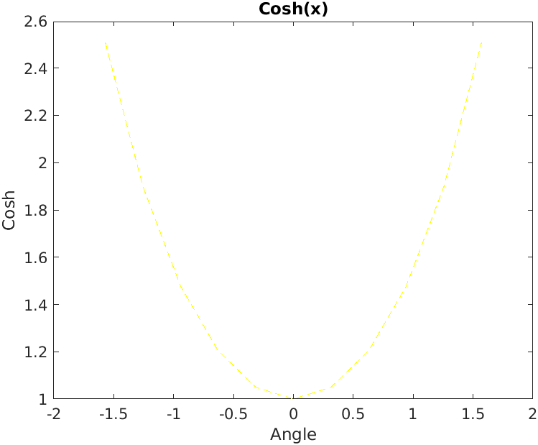

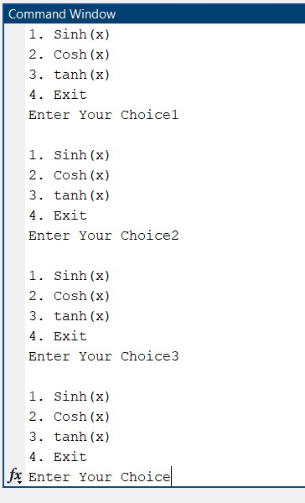

**Q-6.** Write a single MATLAB function hyperbolic to calculate the hyperbolic sine, cosine, and tangent functions as defined in the previous problem. The function should have two arguments. The first argument will be a string containing the function names 'sinh', 'cosh', or 'tanh', and the second argument will be the value of *x* at which to evaluate the function. The file should also contain three subfunctions sinh1, cosh1, and tanh1 to perform the actual calculations, and the primary function should call the proper subfunction depending on the value in the string. [*Note:* Be sure to handle the case of an incorrect number of arguments, and also the case of an invalid string. In either case, the function should generate an error.]

**Code:**

function Question61

x=input('Enter the value of x that is point: ');

fprintf("\nSinh: %f ",hyperbolic('sinh',x));

fprintf("\nCosh: %f ",hyperbolic('cosh',x));

fprintf("\nTanh: %f ",hyperbolic('tanh',x));

end

function n = hyperbolic(typ, x,vararg)

if nargin~=2

error('Invalid Number of arguments');

return;

end

if typ=='sinh'

n = sinh1(x);

elseif typ=='cosh'

n = cosh1(x);

elseif typ=='tanh'

n = tanh1(x);

else

error('Invalid hyperbolic type');

end

end

function s = sinh1(x)

s=(exp(x)-exp(-1*x))./2;

end

function c = cosh1(x)

c=(exp(x)+exp(-1*x))./2;

end

function t = tanh1(x)

t=sinh(x)./cosh(x);

end

**Output:**

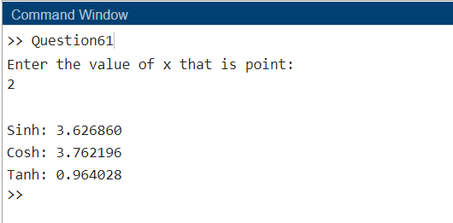

**Q-7.** Write a function that attempts to locate the maximum and minimum values of an arbitrary function over a certain range. The function being evaluated should be passed to the function as a calling argument. The function should have the following input arguments:

first_value—The first value of *x* to search

last_value—The last value of *x* to search

num_steps—The number of steps to include in the search

func—The name of the function to search

The function should have the following output arguments:

xmin—The value of *x* at which the minimum was found

min_value—The minimum value of found

xmax—The value of *x* at which the maximum was found

max_value—The maximum value *f* s*x*d found

Be sure to check that there are a valid number of input arguments, and that the MATLAB help and lookfor commands are properly supported.

**Code:**

function Question7

first_value=input('Enter the First Value: ');

last_value=input('Enter the Last Value: ');

num_steps=input('Enter the Number of Steps: ');

fun=input('Enter the Name of function(cosh,sinh,tanh): ','s');

[xmin, min_value, xmax, max_value] = hyperbolic(first_value, last_value, num_steps, fun)

end

function [xmin, min_value, xmax, max_value] = hyperbolic(first_value, last_value, num_steps, typ,vararg)

if nargin~=4

error('Invalid number of arguments');

return;

end

x=first_value:num_steps:last_value;

if typ=='sinh'

s=sinh(x);

[min_value, xmin]=min(s);

[max_value, xmax]=max(s);

elseif typ=='cosh'

c=cosh(x);

[min_value, xmin] = min(c);

[max_value, xmax] = max(c);

elseif typ=='tanh'

t=tanh(x);

[min_value, xmin] = min(t);

[max_value, xmax] = max(t);

else

error('Invalid hyperbolic type');

end

end

function s = sinh(x)

s=(exp(x)-exp(-x))./2;

end

function c = cosh(x)

c=(exp(x)+exp(-x))./2;

end

function t = tanh(x)

t=sinh(x)./cosh(x);

end

**Output:**

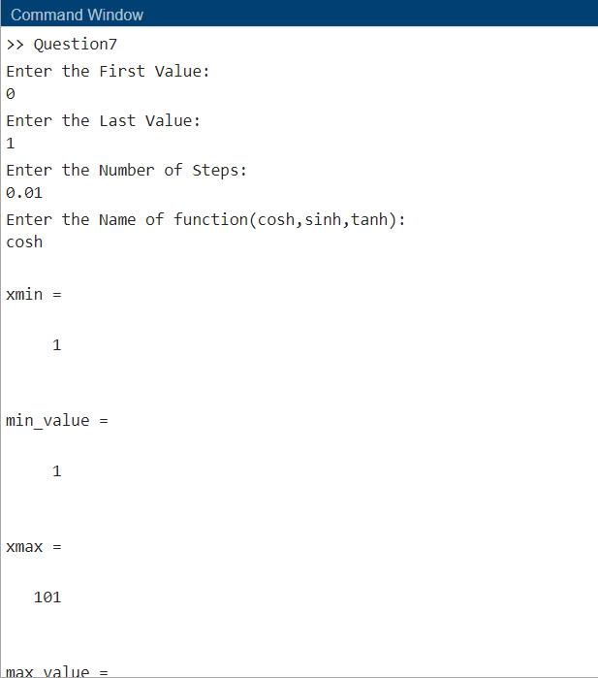

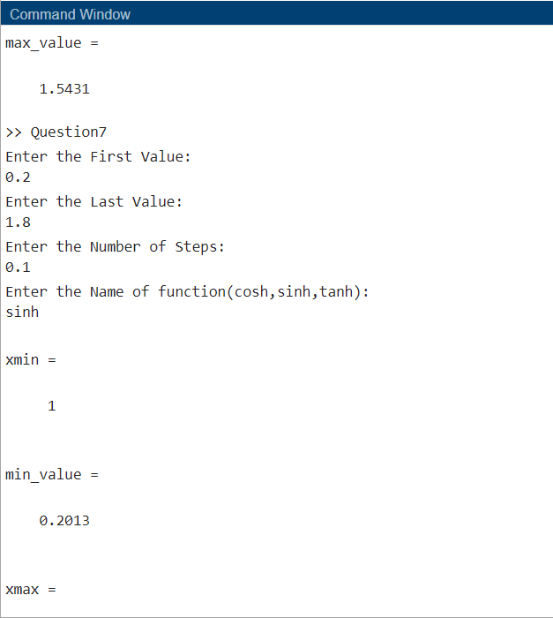

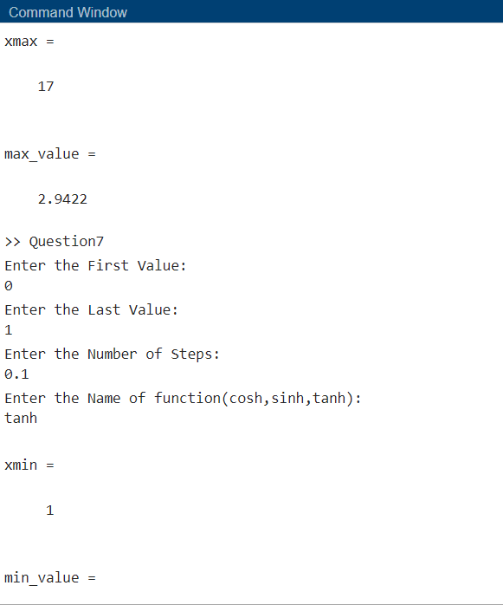

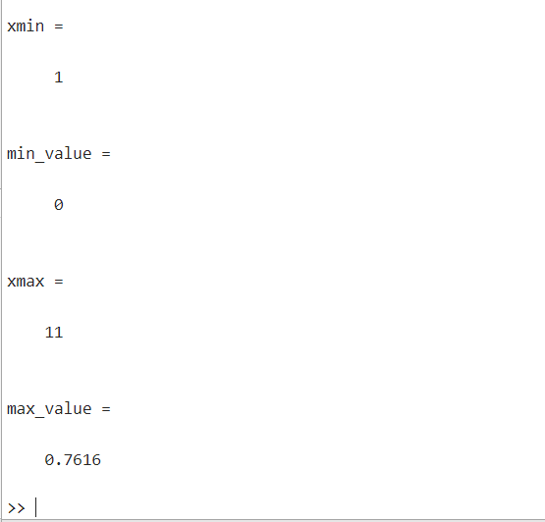

**Q-8.** The gravitational force *F* between two bodies of masses and is given by the equation



where G is the gravitation constant (6.672 x 10-11 N m2 / kg2), m1 and m2 are the masses of the bodies in kilograms, and *r* is the distance between the two bodies. Write a function to calculate the gravitational force between two bodies given their masses and the distance between them. Test you function by determining the force on an 800 kg satellite in orbit 38,000 km above the Earth. (The mass of the Earth is 5.98 x 1024 kg.)

**Code:**

function Question8

m1=input('\nEnter the Mass of Body 1: ');

m2=input('\n\nEnter the Mass of Body 2: ');

r=input('\n\nEnter the distance between Mass 1 and Mass 2: ');

x=F(m1,m2,r);

fprintf("\n\nForce: %f",x);

end

function F = F(m1,m2,r)

G=6.672e-11;

F=G*m1*m2/r^2;

end

**Output:**

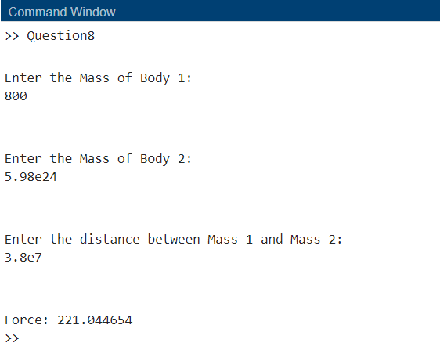

**Conclusion:**

From this experiment we came to understand the concepts of MATLAB’s inbuilt functions that is variable arguments and plotting sinusoidal curves and mainly functions. We learnt the function calling methods and function defining methods. Using functions, we can easily reuse the piece of code or statements whenever needed.